**MATLAB Assignment 2**

*Ayswarya Padmanabhan 2301998*

*Task 1.*

From the Plot of the ellipse, we observe that the bodies collide.

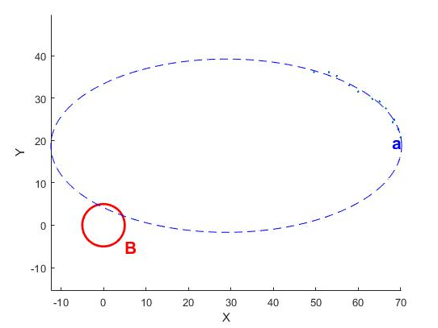

Task 2.

Answers:

PFA= 0.000062 ,Threshold = -78.121331 dBm, Noise Floor = -90.996007.

Pulse Duration= 0.000006 sec, Pulse Period = 0.001000 sec,

threshold = -66.564589dB.

2.3 Answer:

Following are the factors that are to be considered while designing Threshold

1. Depends on the number of averaging
2. Many number of averaging reduces the noise variance
3. Non coherent combining across frames improves the noise suppression.

2.5 Answer: Handling very weak Signals

1. Non coherent combining across frames to enhance signal detection probability (when frequency offset is present).

2. Coherent combining across frames can be considered when there is no frequency offset.